NEXTHIKE IT SOLUTION
PROJECT: BUILDING BASIC CALCULATOR USING PYTHON

WE ARE ALL AWARE OF THE NEED OF CALCULATOR. THESE DAYS IT HELPS US IN EVERY POINT OF LIFE. ACKNOWLEDGING THE NEED WE SHOULD LEARN HOW TO MAKE A BASIC CALCULATOR USING PYTHON.
THOUGH WE ARE MAKING A SCIENTIFIC CALCULATOR WHICH IS ADVANCE AND MORE RELEVANT FOR TODAY’S LIFE. A SCIENTIFIC CALCULATOR CONTAINS NOT ONLY FUNCTIONS LIKE ADDITION, SUBTRACTION, MULTIPLICATION AND DIVISION BUT ALSO ADVANCE FUNCTION LIKE TRIGNOMETRIC FUNCTIONS SUCH AS SINE, COSINE, TANGENT AND LOGARITHMIC AND EXPONENTIAL FUNCTION.

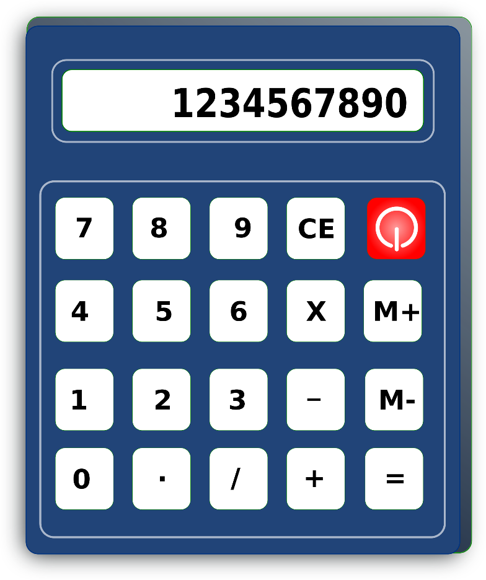
THIS IS A PHYSICAL CALCULATOR WE GENERALLY USE IN DAILY LIFE. A DIGITAL CALCULATOR USING GRAPHICAL USER INTERFACE IS MUCH MORE USEFUL.

THIS IS A CALCULATOR HAVE BEEN MADE WITH VISUAL STUDIO CODE AND TKINTER LIBRARY.
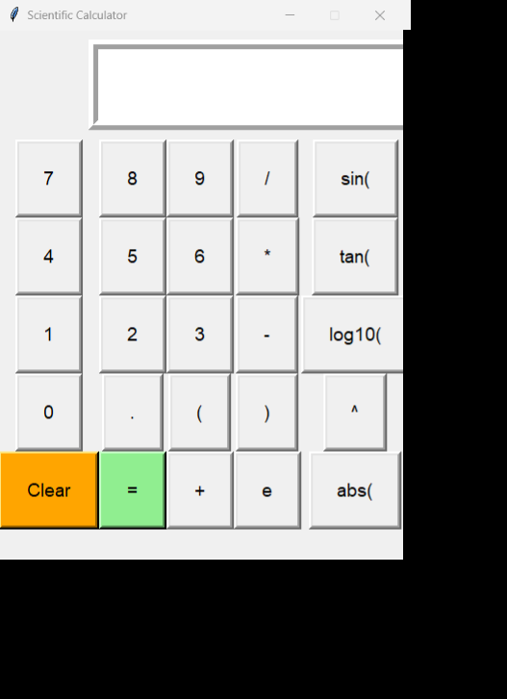

TKINTER LIBRARY IS AS THE STANDARD PYTHON INTERFACE FOR CREATING GRAPHICAL USER INTERFACES AND COMES BUNDLED WITH THE PYTHON STANDARD LIBRARY.
TKINTER PROVIDES A RANGE OF WIDGETS SUCH AS BUTTONS, LABELS, TEXT BOXES ETC.
1ST, THE BASIC ARITHMATIC FUNCTIONS HAVE BEEN ENTERED.
THEN, TRIGNOMETRIC, EXPONENTIAL AND LOGARITHMIC FUNCTION.
THEN, ADDED THE BUTTONS AND OUR BASIC SCIENTIFIC CALCULATOR IS READY TO GO.

FEATURES:
1.THIS SCIENTIFIC CALCULATOR IS EASY TO USE.
2.IT HAS ALL THE BASIC AND ADVANCE KEYS.
3.RELEVANT AND CAN FULFILL THE BASIC NEEDS.
4.GIVES FAST AND SEAMLESS EXECUTION OF MATHEMETICAL CALCULATIONS.
5.THROWS ERROR IF ANY WRONG OPERATIONS PUT IN.

THANK YOU!

